Testing Checklist
Testing question | Yes/No | Evidence or notes
Does the prototype open/start correctly? | Yes | 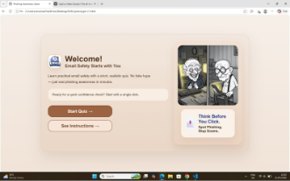
Is the welcome/title screen clear? | Yes
Are the instructions easy to understand? | Yes | 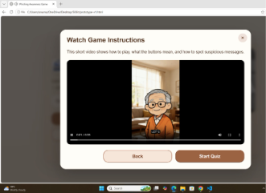
Can the player identify what to click/do? | Yes | 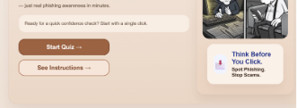
Does the first cyber-safety challenge work? | Yes | 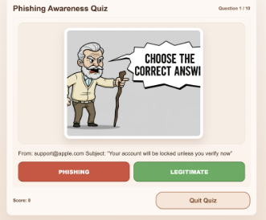
Does any new challenge/interaction work? | In progress
Does the correct answer show useful feedback? | Yes | 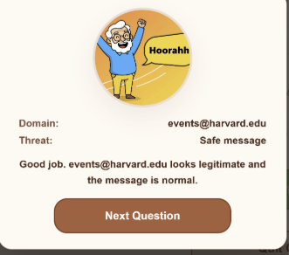
Does the wrong answer show helpful feedback? | Yes | 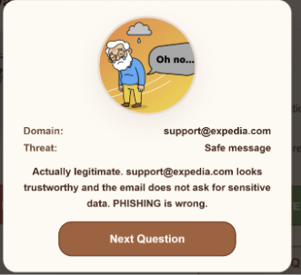
Does the feedback teach a cyber-safety lesson? | Yes | 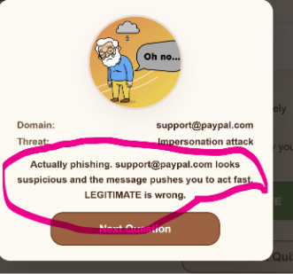
Is there a reward, score, star, badge or progress message? | Yes | 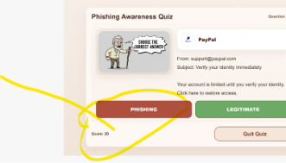
Is the prototype suitable for the target audience? | Yes | We have use older cartoon characters to match the audience and the theme which is easy for targeted audience to see  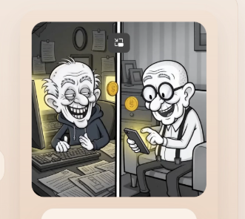
What must be improved before next week? | The question Display need to be improved and feedback area  As the Way of asking the question is bit simple so we will try to make it attractive. | 